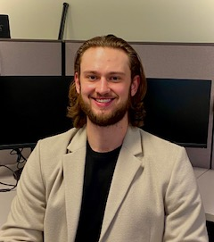 Michael Warnick
Property Facilitator

Michael is a detailed-oriented, business-minded broker, who brings his experience in property management, his commitment and dedication to all clients, owners, and to all project managed by SUHRCO. Michael brings insight, communication and organizational skills to SUHRCO gained from all aspects of his life, including experiences gained from working at the King County Council where he conducted and analyzed ordinances, motions, budgets, and laws while communicating directly with the council members and the citizens of King County. Michael believes not only doing the expected but going above and beyond and strives to exceed the expectations of our clients.

Michael graduated from the University of Puget Sound with a Bachelor Degree in Business Administration while minoring in economics. In additional to his academic pursuits, he played on the University Baseball Team all four years, receiving All Northwest Conference Honors and Student Athlete Awards. Michael continued with his Baseball Career after being recruited to play on an International Team based in Australia. Upon returning to the United States, Michael began working for SUHRCO assisting in research, property inspections, working with contractors obtaining bids for Capital Improvement projects and assisting with various special commercial, residential and corporate projects. He has continued to expand his Real Estate Education/Certifications (with CIA and IREM) and participates in various local charities/non-profits, as well as supporting the Fred Hutchinson Cancer Research Institute and Hopelink.

When not at work, Michael enjoys golfing, skiing, and Martial Arts.

